NAME : Manasseh. M
Topic : Data Analyst

Task: Comprehensive Data Analysis Reporting and Presentation

1. INTRODUCTION
Data analysis is an important process used to collect, clean, analyze, visualize, and interpret data in order to obtain meaningful insights. This comprehensive report presents the complete analysis of the Titanic dataset using the R programming language. The report integrates the work completed during the previous three weeks, including data cleaning and preliminary analysis, data visualization and insight communication, and statistical analysis with predictive modeling.

2. DATASET OVERVIEW
The Titanic dataset was selected for this project because it is suitable for data cleaning, visualization, statistical analysis, and predictive modeling. The dataset contains both numerical and categorical variables, making it useful for performing different types of analysis.
The dataset contains 891 passenger records and 12 columns. The important variables include passenger survival status, passenger class, name, gender, age, number of siblings or spouses, number of parents or children, ticket information,
titanic_data <- read.csv("Titanic-Dataset.csv")
head(titanic_data)
dim(titanic_data)
str(titanic_data)
summary(titanic_data)
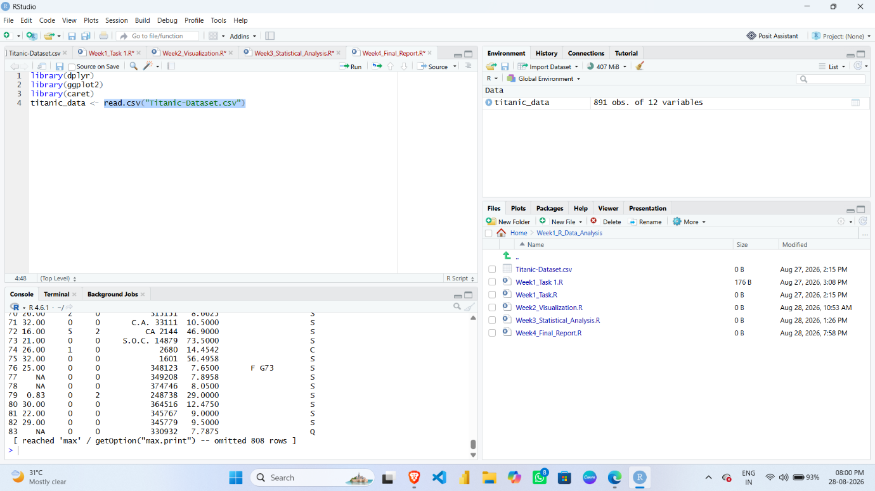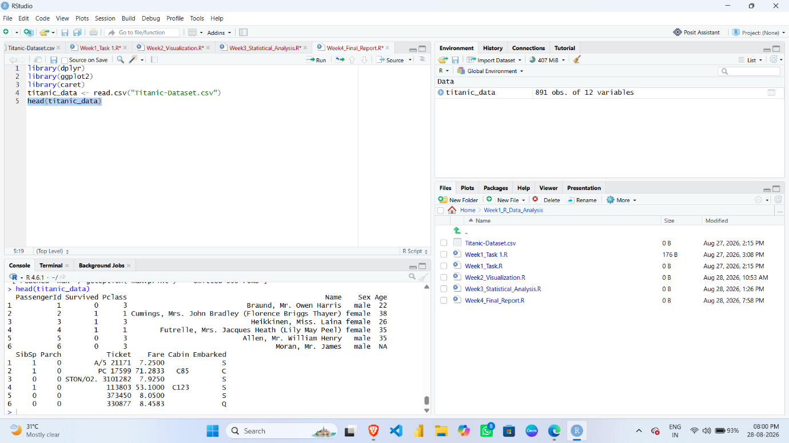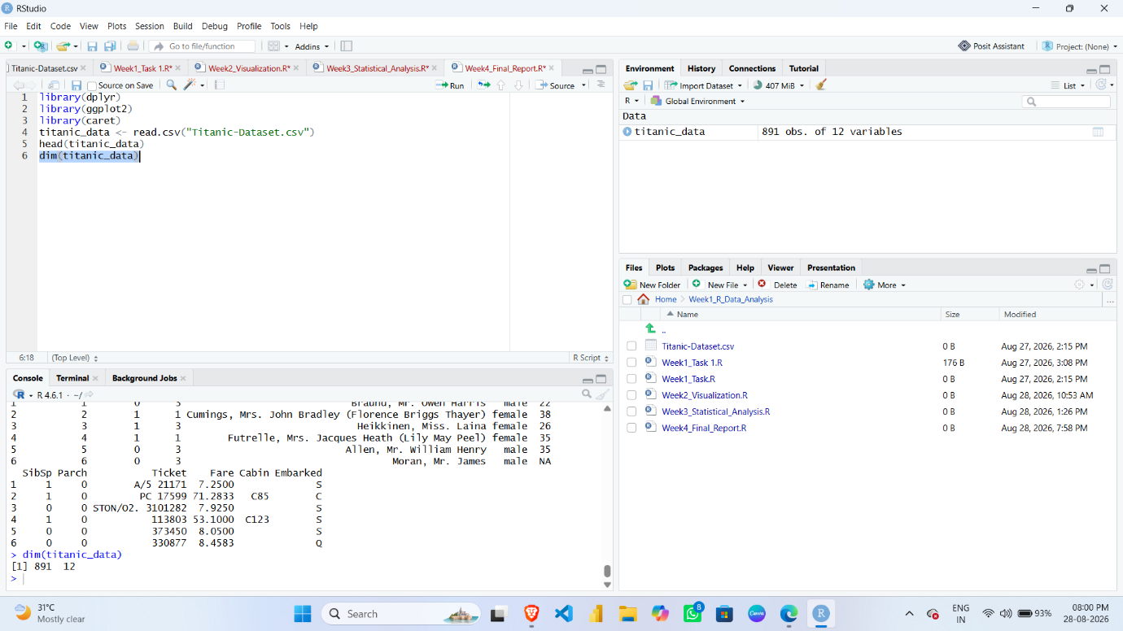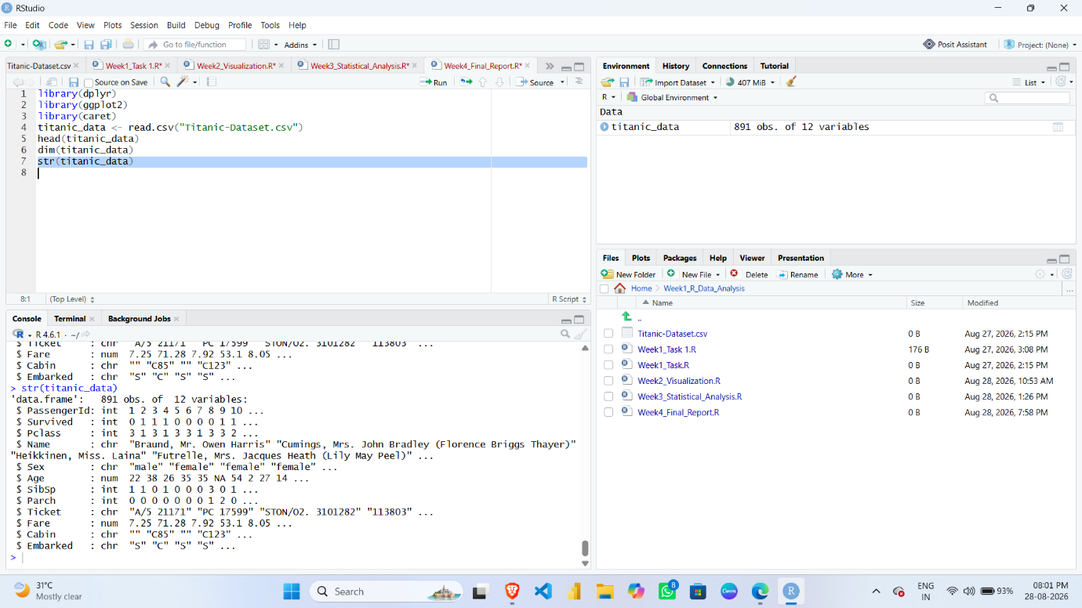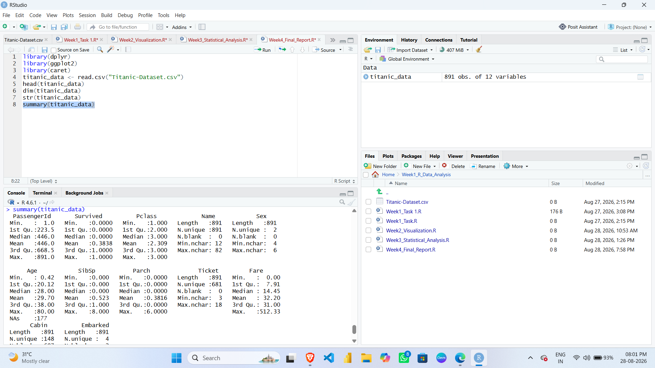

3. METHODOLOGY
The project was completed using a structured data analysis methodology. The complete workflow started with dataset selection and ended with predictive model evaluation.
The first stage involved importing the Titanic dataset into RStudio and understanding its structure. The dataset was then checked for missing values and cleaned before further analysis. After data preparation, exploratory analysis was performed using descriptive statistics.

4. DATA PREPARATION AND CLEANING
Data cleaning is an important step because raw datasets may contain missing values, inconsistent data, or variables that require preprocessing. Before performing visualization and predictive modeling, the Titanic dataset was checked for missing values.
The following R code was used to identify missing values in each column:
colSums(is.na(titanic_data))
The analysis identified missing values in variables such as Age and Embarked. These missing values were handled before continuing with further analysis.
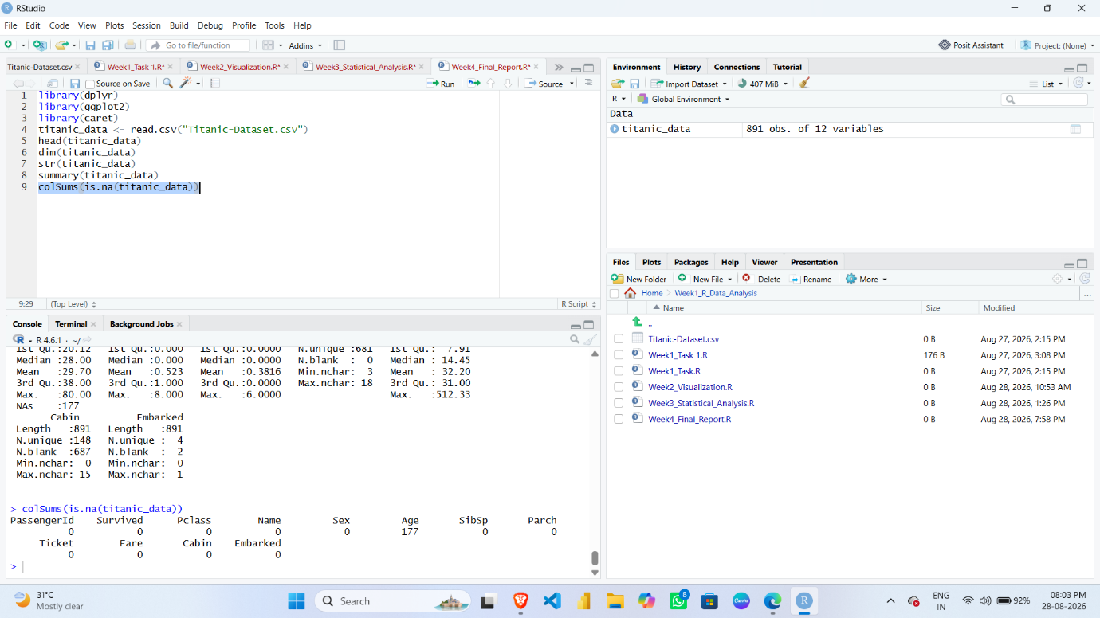
4.1 Handling Missing Values in Age
Age is a numerical variable. Missing Age values were replaced using the median value of the available Age observations. The median was selected because it is less affected by extreme values compared with the mean.

R Code
titanic_data$Age[is.na(titanic_data$Age)] <-
median(titanic_data$Age, na.rm = TRUE)
sum(is.na(titanic_data$Age))-
SCREENSHOT 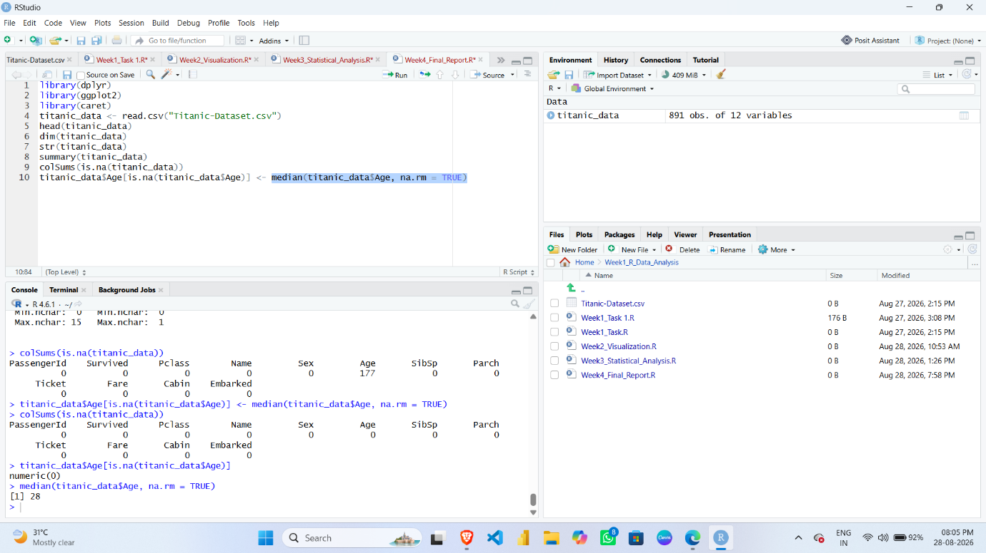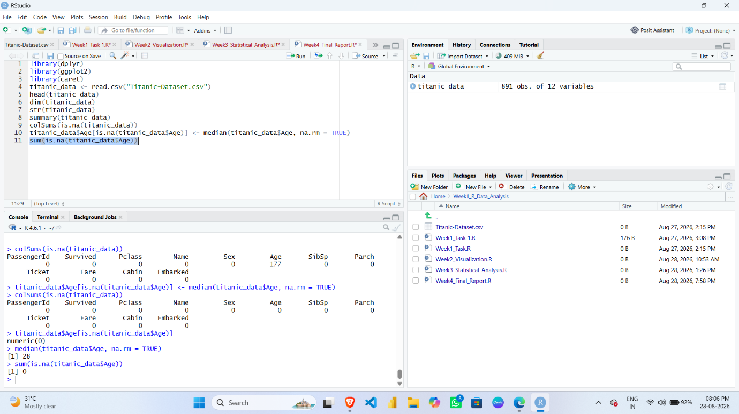
4.2 Handling Missing Values in Embarked
Embarked is a categorical variable.
Missing values in this column were replaced using the most frequently occurring category, also known as the mode.
R Code
mode_embarked <- names(sort(table(titanic_data$Embarked),
decreasing = TRUE))[1]

titanic_data$Embarked[is.na(titanic_data$Embarked)] <-
mode_embarked
After handling the missing values, the column was checked again.
sum(is.na(titanic_data$Embarked))

SCREENSHOT
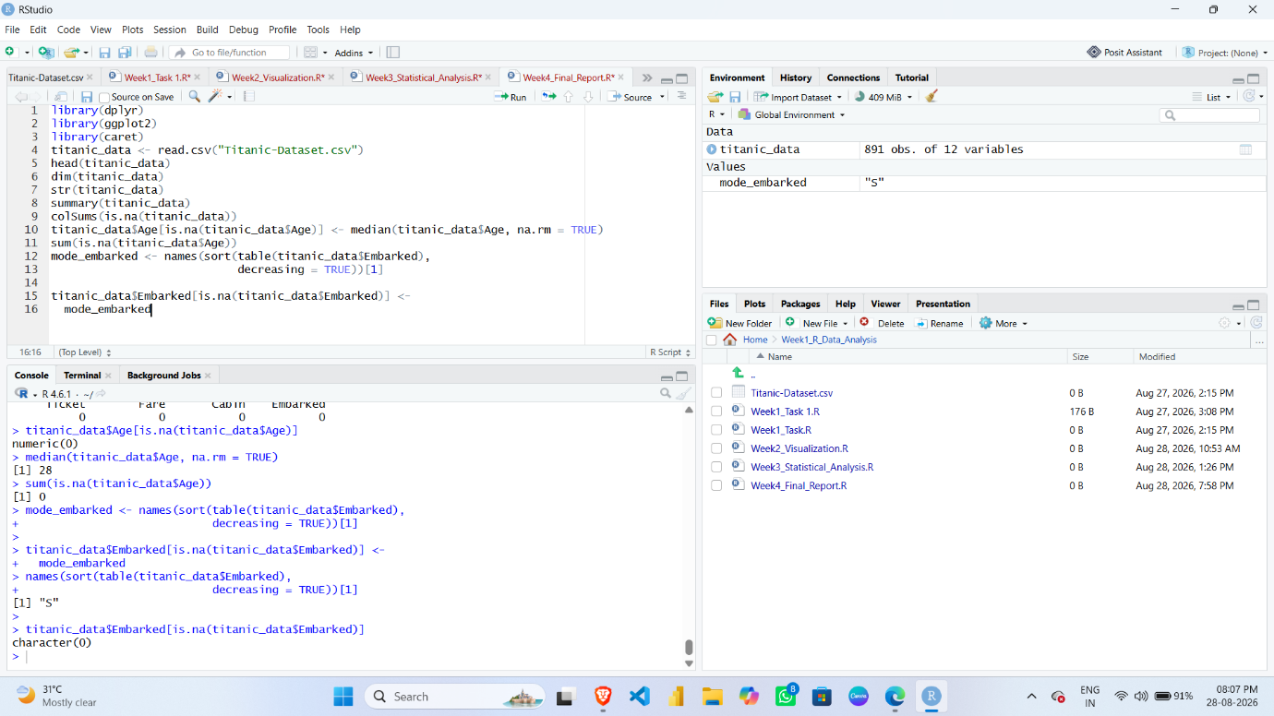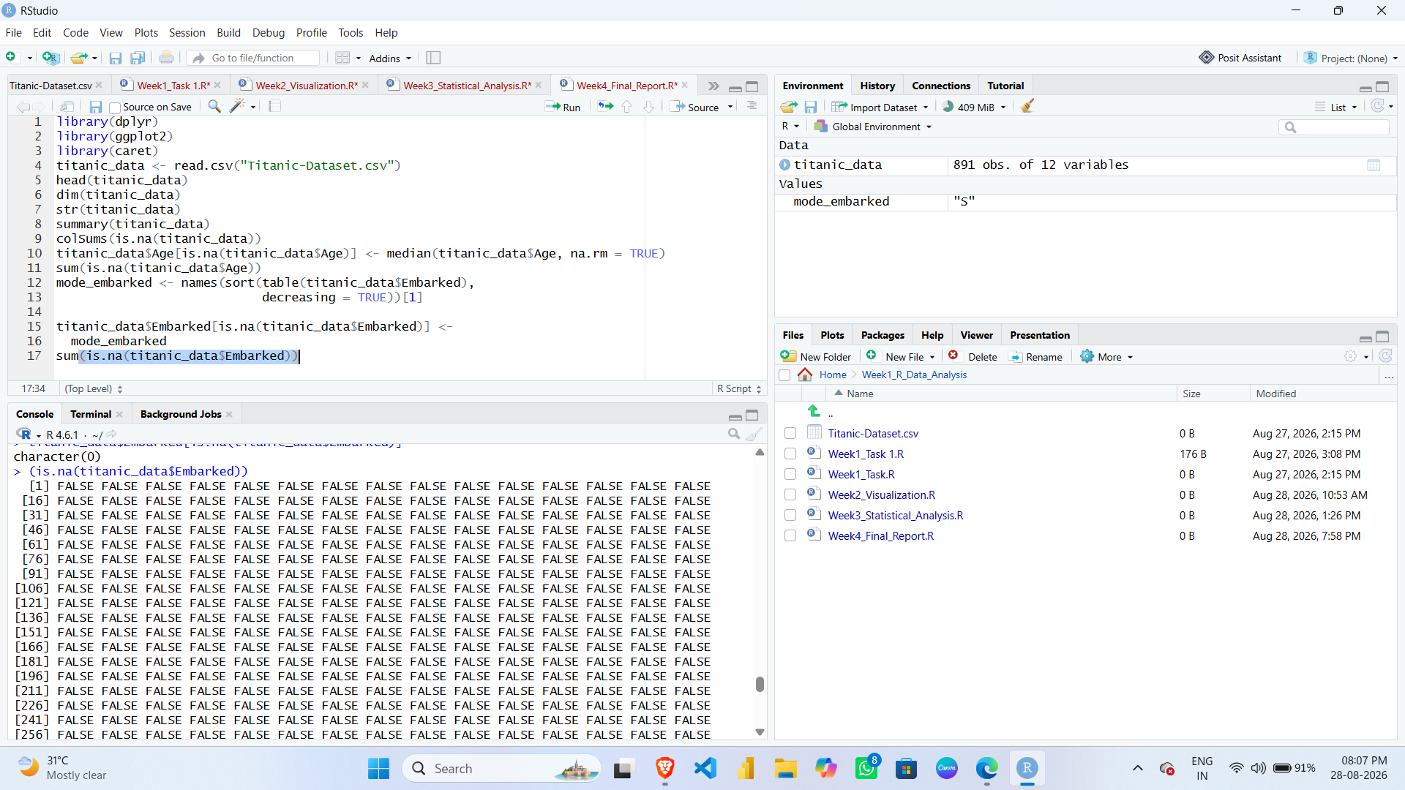

5. EXPLORATORY DATA ANALYSIS
Exploratory Data Analysis was performed to understand the characteristics and distribution of the Titanic dataset. The summary() function was used to generate descriptive statistics for the available variables.
R Code
summary(titanic_data)
SCREENSHOT
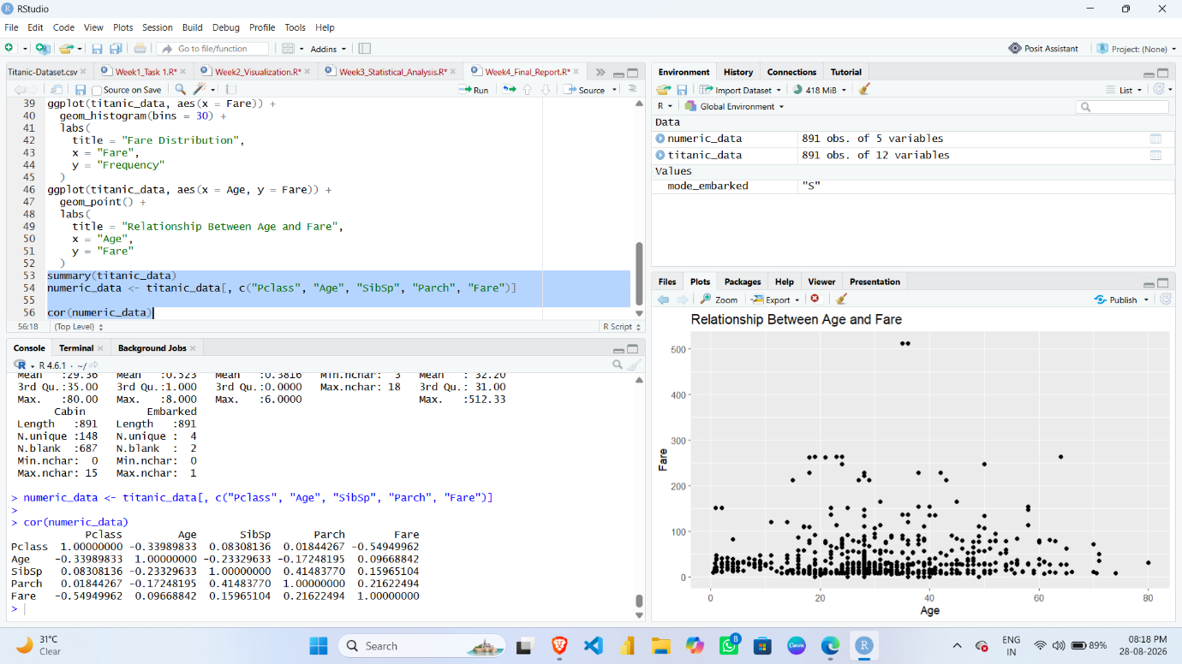

6. DATA VISUALIZATION AND INSIGHT COMMUNICATION
6.1 Survival Count
R Code
ggplot(titanic_data, aes(x = factor(Survived))) +
geom_bar() +
labs(
title = "Survival Count",
x = "Survival Status",
y = "Number of Passengers"
)
SCREENSHOT
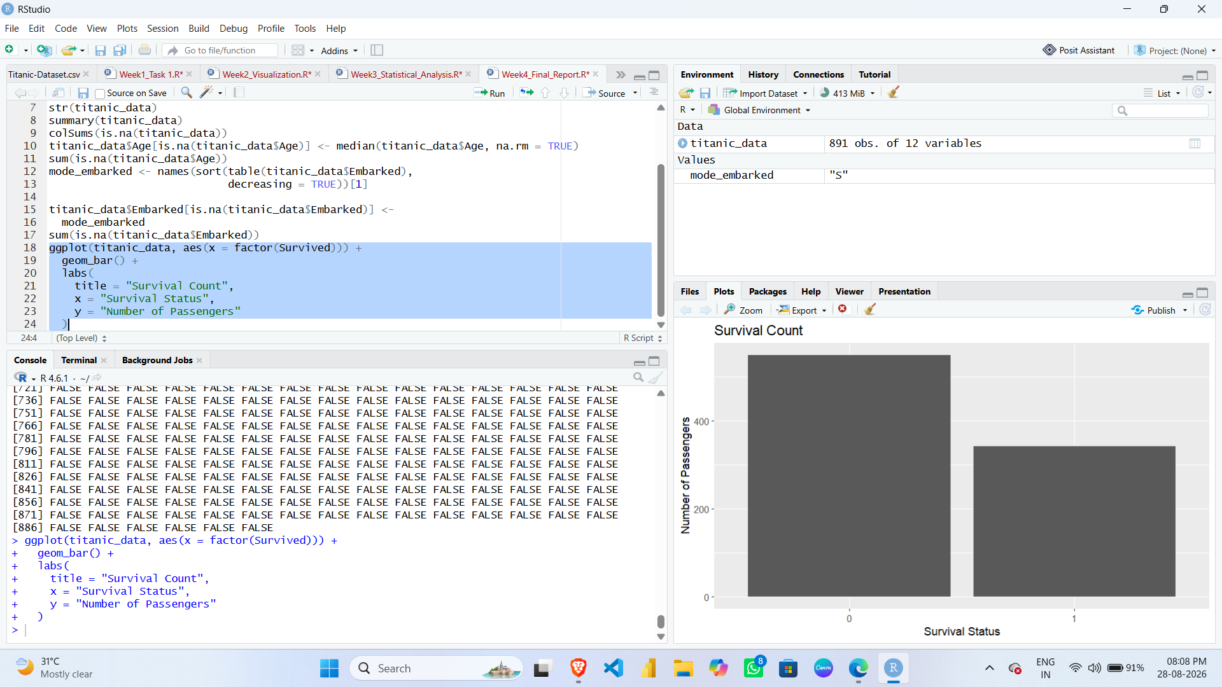

6.2 Survival by Gender
R Code
ggplot(titanic_data, aes(x = Sex, fill = factor(Survived))) +
geom_bar(position = "dodge") +
labs(
title = "Survival by Gender",
x = "Gender",
y = "Number of Passengers"
)
SCREENSHOT
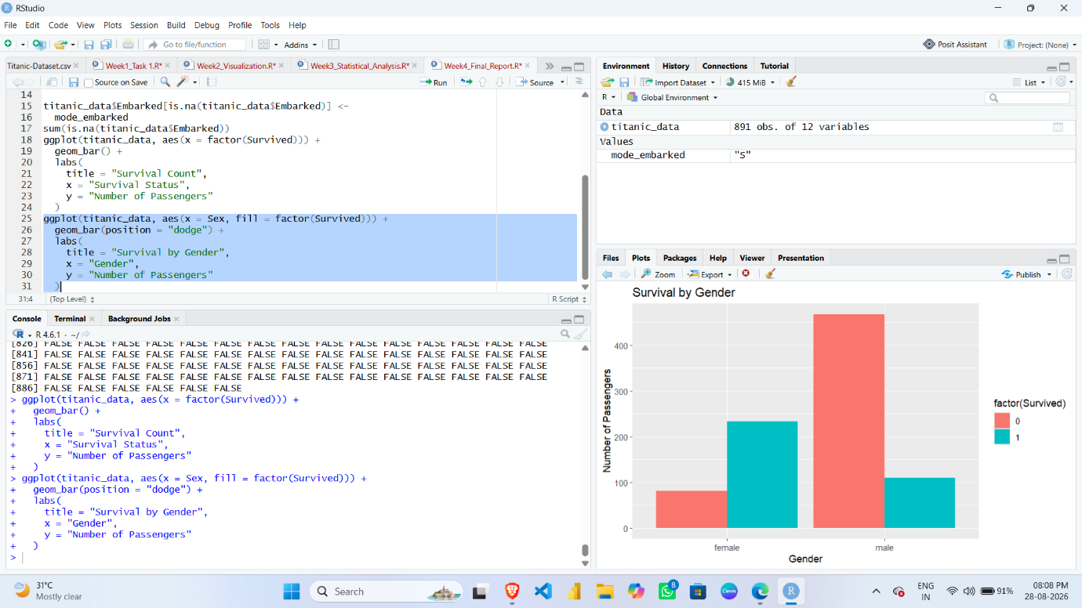

6.3 Survival by Passenger Class
R Code
ggplot(titanic_data, aes(x = factor(Pclass), fill = factor(Survived))) +
geom_bar(position = "dodge") +
labs(
title = "Survival by Passenger Class",
x = "Passenger Class",
y = "Number of Passengers"
)
SCREENSHOT

6.4 Age Distribution
R Code
ggplot(titanic_data, aes(x = Age)) +
geom_histogram(bins = 30) +
labs(
title = "Age Distribution",
x = "Age",
y = "Frequency"
)
SCREENSHOT
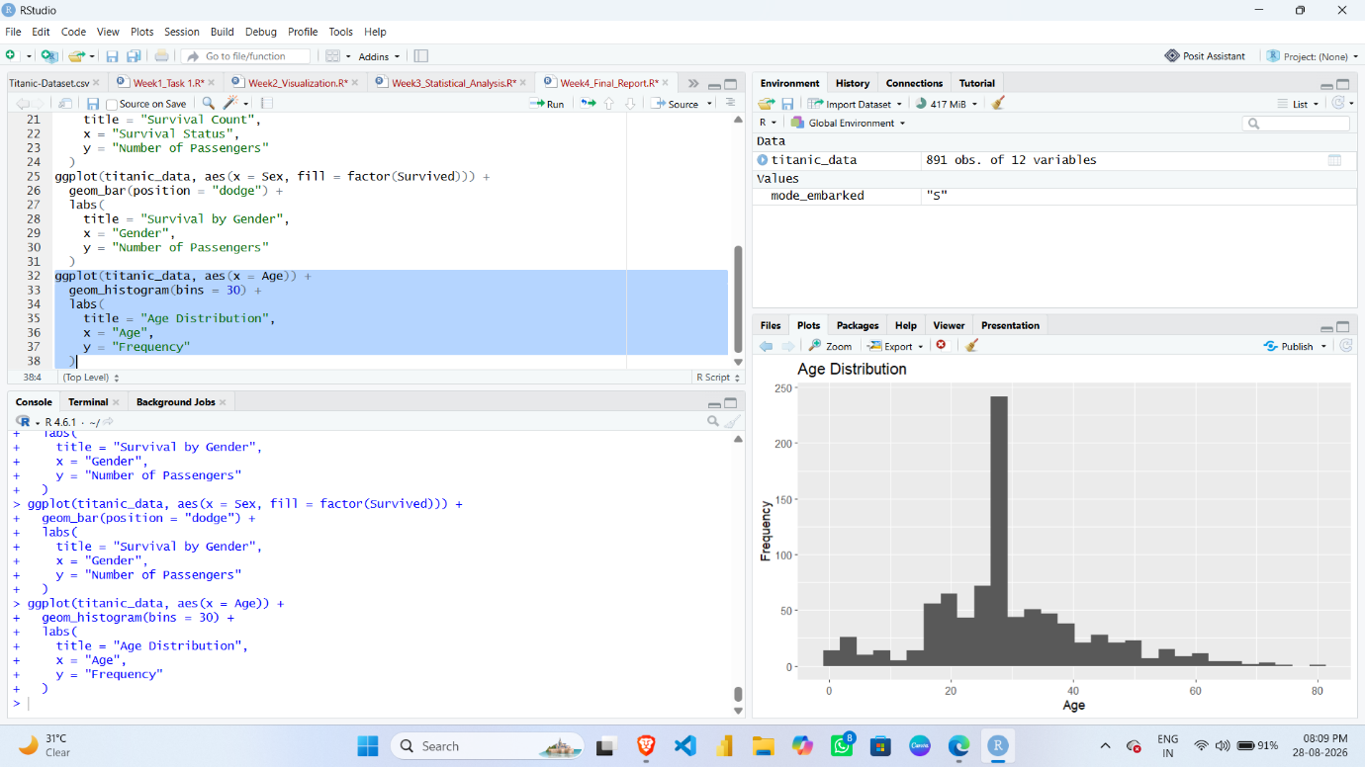

6.5 Fare Distribution
R Code
ggplot(titanic_data, aes(x = Fare)) +
geom_histogram(bins = 30) +
labs(
title = "Fare Distribution",
x = "Fare",
y = "Frequency"
)

SCREENSHOT
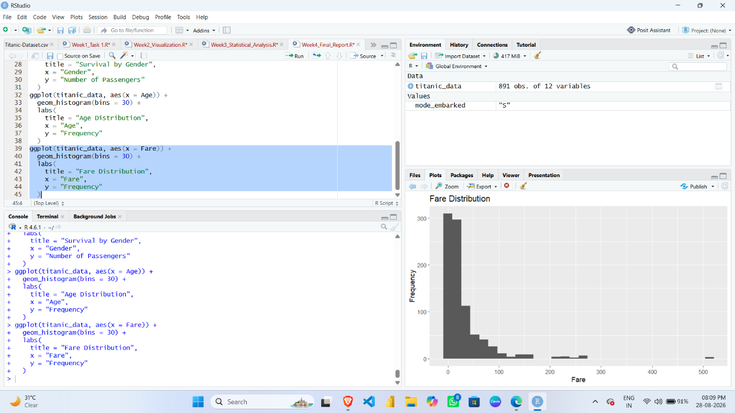

6.6 Relationship Between Age and Fare
R Code
ggplot(titanic_data, aes(x = Age, y = Fare)) +
geom_point() +
labs(
title = "Relationship Between Age and Fare",
x = "Age",
y = "Fare"
)
SCREENSHOT
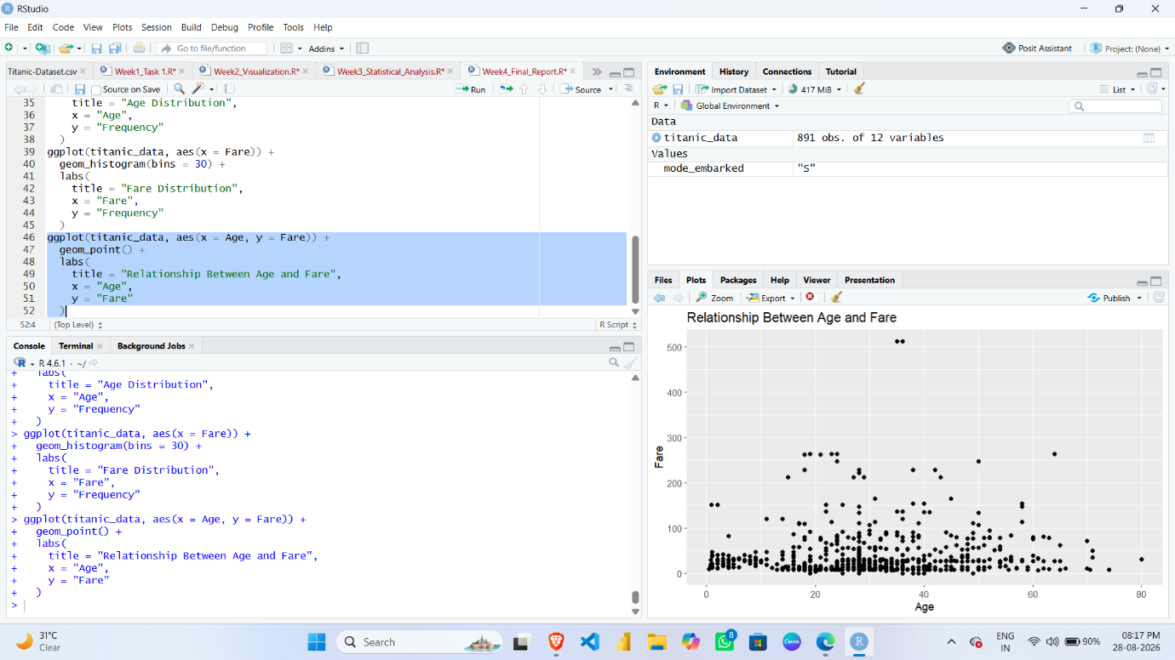
7. STATISTICAL ANALYSIS

7.1 Correlation Analysis
Correlation analysis was performed using important numerical variables.
R Code
numeric_data <- titanic_data[, c(
"Pclass","Age", "SibSp","Parch","Fare"
)]

cor(numeric_data)
SCREENSHOT

8. HYPOTHESIS TESTING
Hypothesis testing was performed to examine the relationship between Gender and Survival.
Null Hypothesis (H₀)
There is no significant association between gender and survival.
Alternative Hypothesis (H₁)
There is a significant association between gender and survival.
A Chi-Square Test was used for this analysis.
R Code
survival_gender <- table(
titanic_data$Sex,
titanic_data$Survived)

chisq.test(survival_gender)
SCREENSHOT
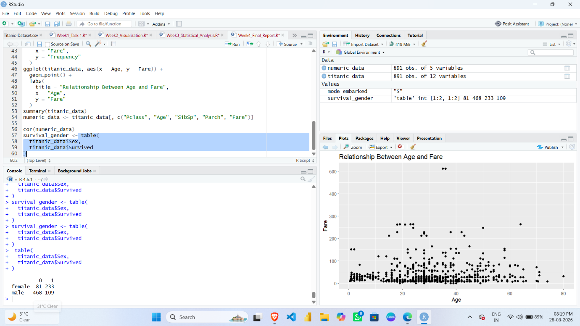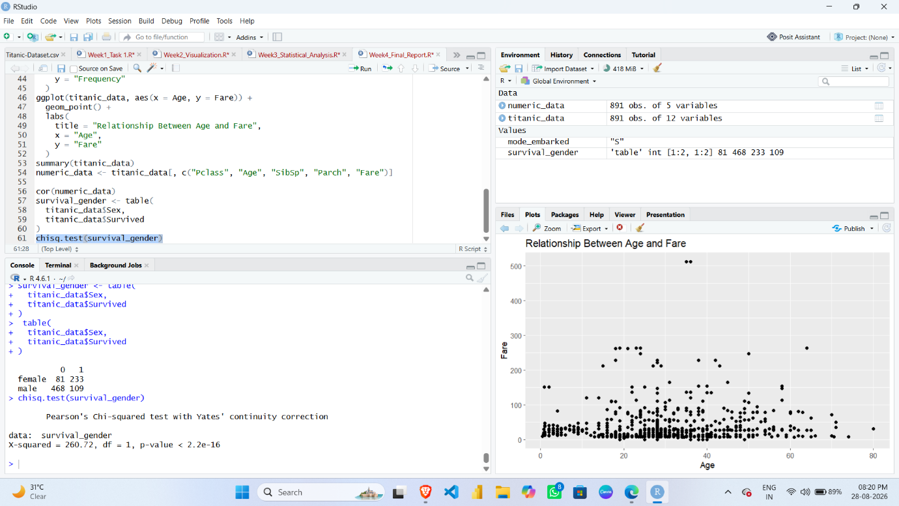

9. PREDICTIVE MODELING
The final stage of the analysis involved building a predictive model to predict passenger survival.
The target variable was:
Survived

9.1 Creating Model Data
R Code
model_data <- titanic_data %>%
select(Survived, Pclass, Sex, Age, SibSp, Parch, Fare)

model_data$Sex <- as.factor(model_data$Sex)
model_data$Survived <- as.factor(model_data$Survived)
SCREENSHOT
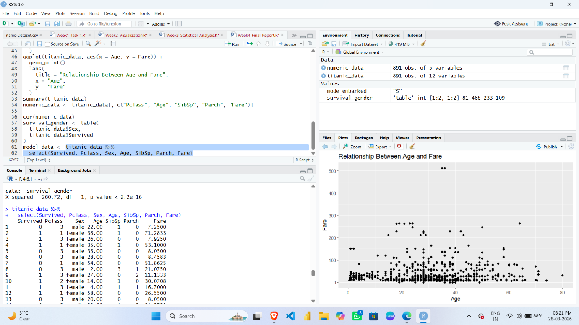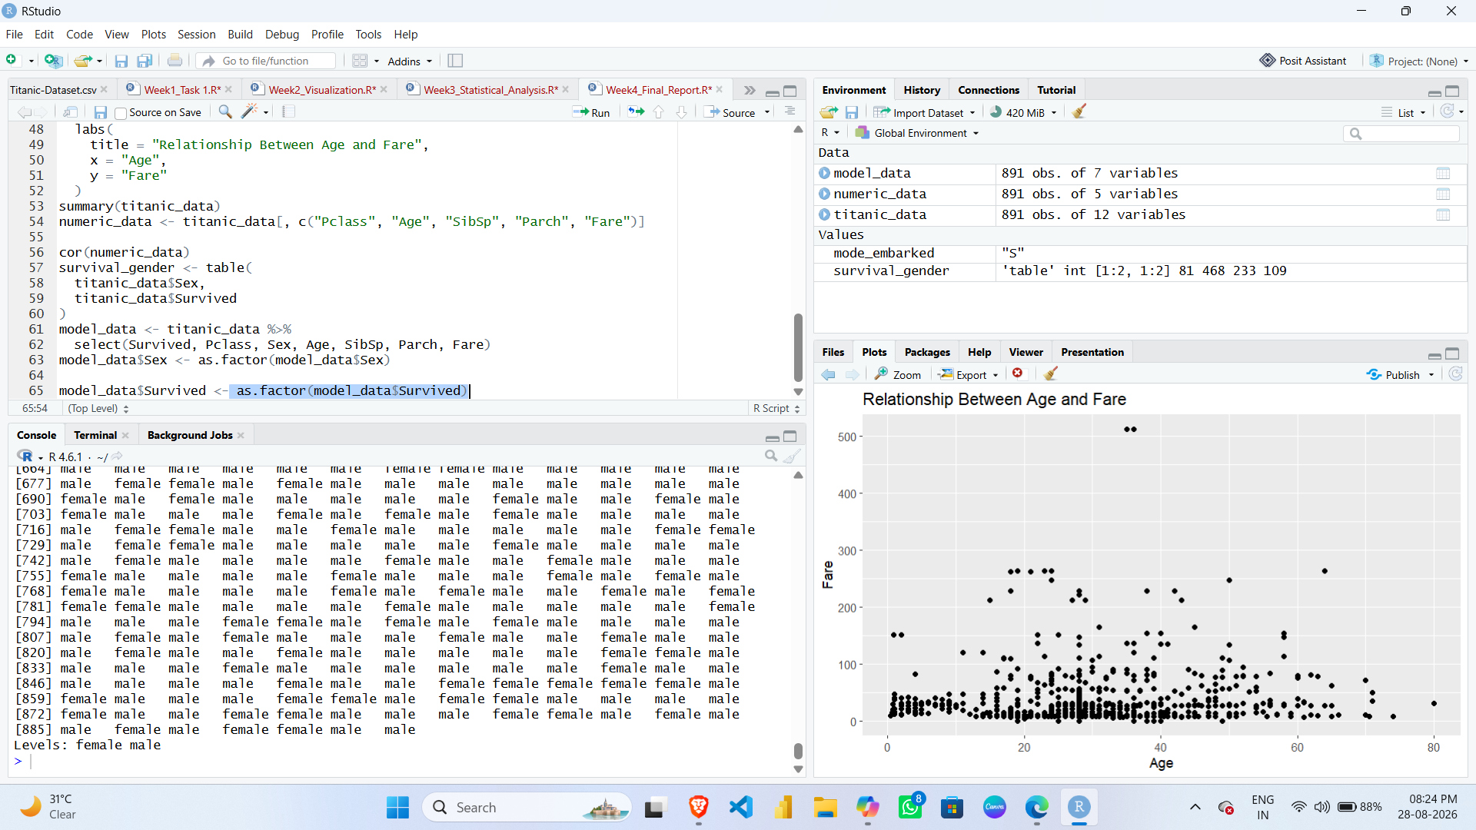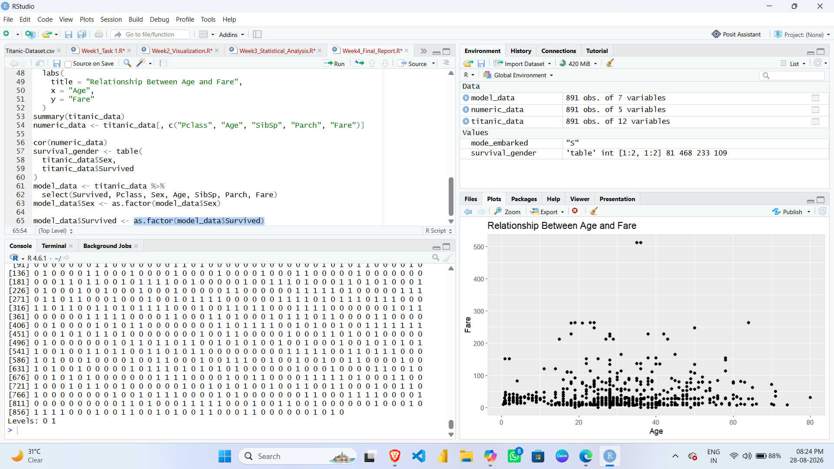

9.2 Training and Testing Data Split
The dataset was divided into two parts:
- 80% Training Data
- 20% Testing Data
R Code
set.seed(123)
train_index <- createDataPartition(
model_data$Survived,
p = 0.80,
list = FALSE
)
train_data <- model_data[train_index, ]
test_data <- model_data[-train_index, ]

dim(train_data)
dim(test_data)
SCREENSHOT
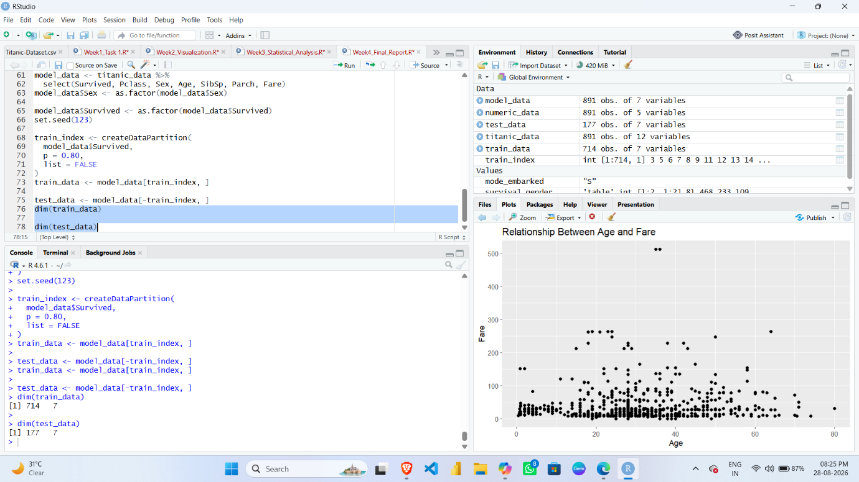
9.3 Logistic Regression Model
R Code
model <- glm(
Survived ~ Pclass + Sex + Age + SibSp + Parch + Fare,
data = train_data,
family = binomial
)
summary(model)
SCREENSHOT
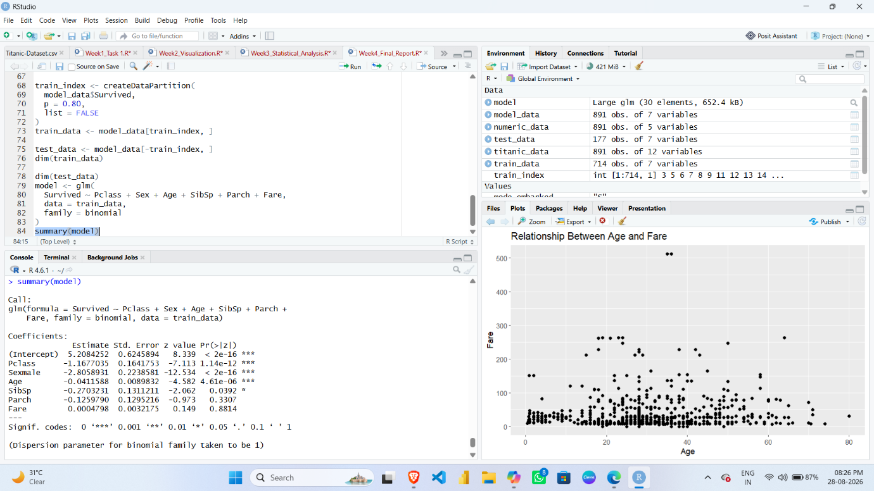

10. PREDICTION
The trained model was used to generate predictions for the testing dataset.
R Code
predicted_prob <- predict(
model,
test_data,
type = "response"
)

predicted_class <- ifelse(
predicted_prob > 0.5,
"1",
"0"
)

predicted_class <- factor(
predicted_class,
levels = c("0", "1")
)
SCREENSHOT 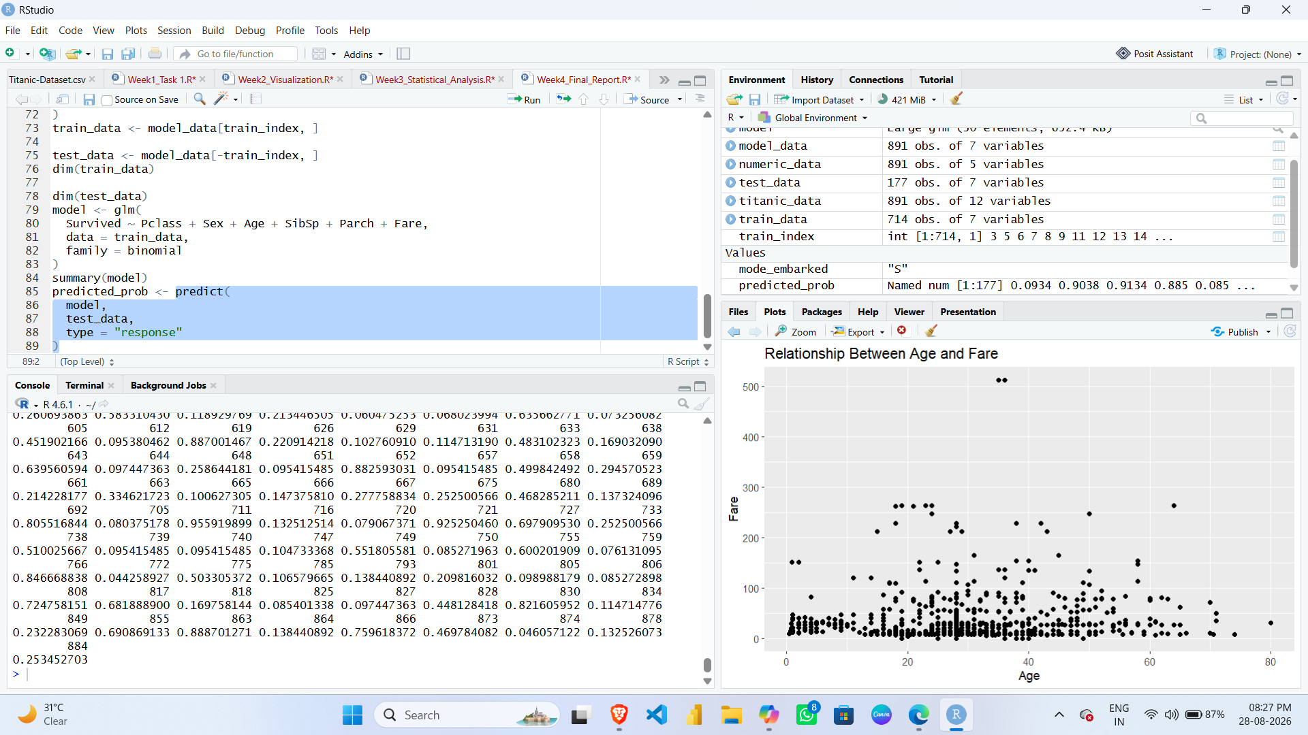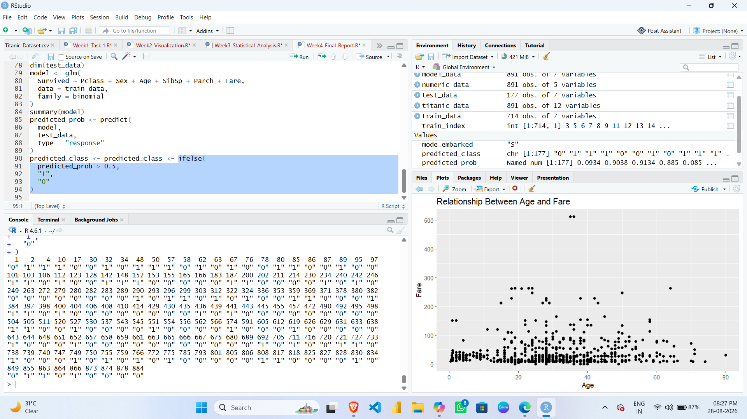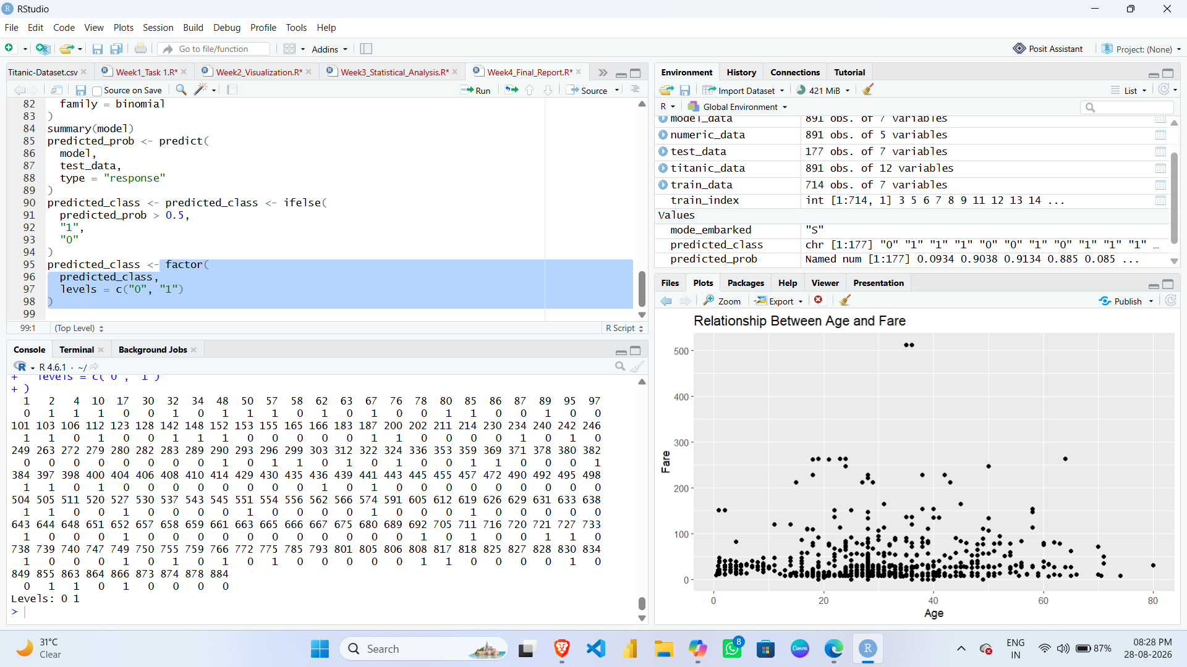

11. MODEL EVALUATION
The performance of the Logistic Regression model was evaluated using a confusion matrix.
R Code
confusionMatrix(
predicted_class,
test_data$Survived
)
SCREENSHOT
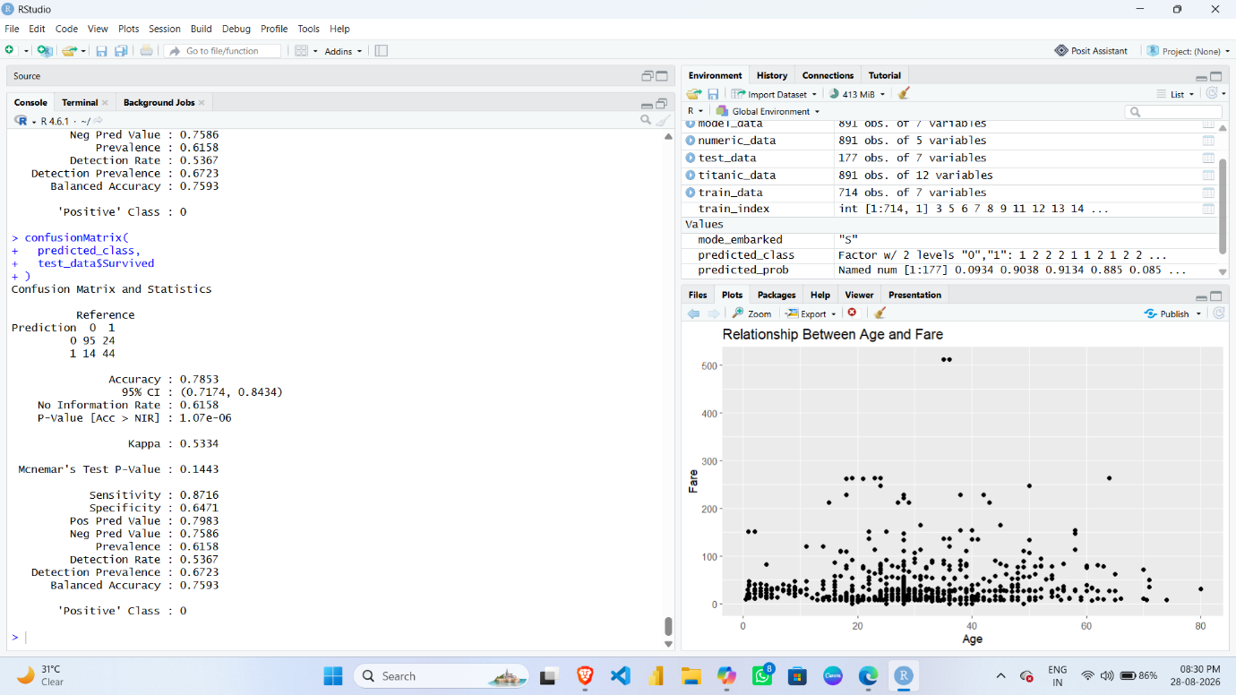

11.1 Model Accuracy
R Code
mean(predicted_class == test_data$Survived) * 100

SCREENSHOT
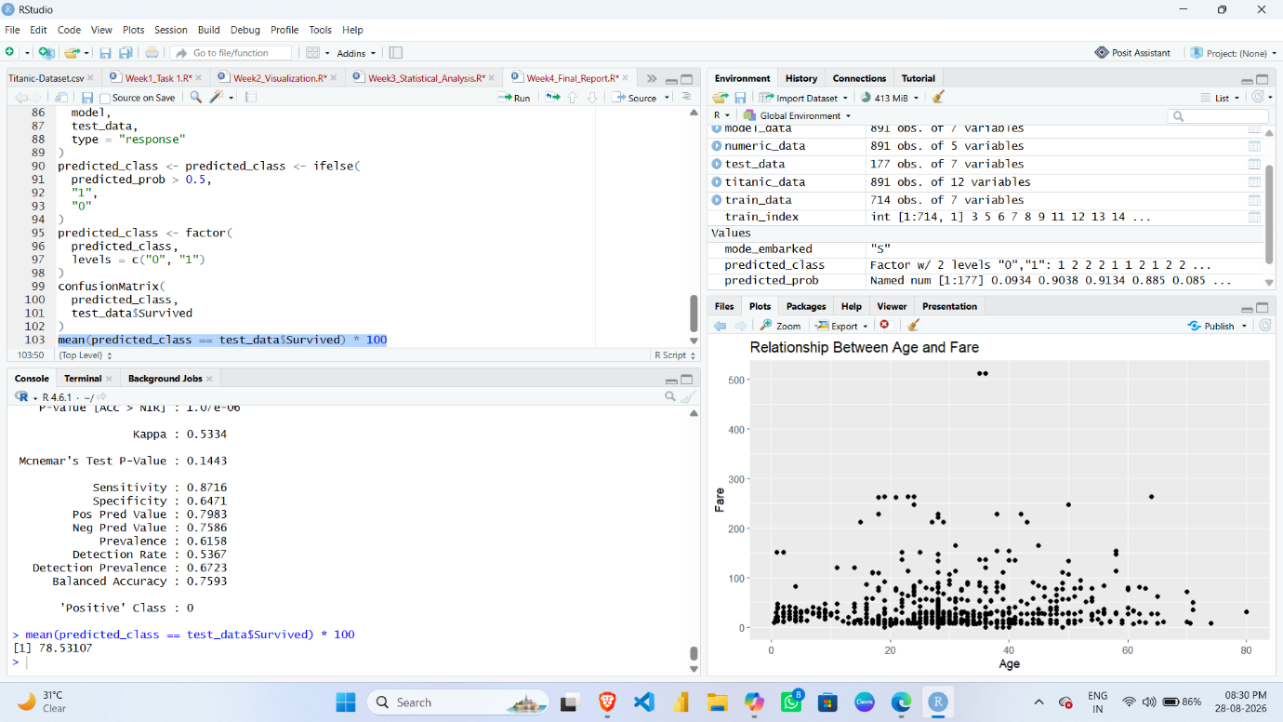
12. MODEL DIAGNOSTICS
R Code
plot(model)
Diagnostic plots can help in identifying patterns, unusual observations, and possible limitations in the model.

SCREENSHOT
